Wavelet correlation and coherence: USDCHF and USDCAD
Method 22 / daily log returns / Morlet CWT / Alpari D1 full available history

Study setup
Logical pair: USDCHF , USDCAD
Broker symbols: USDCHF_i , USDCAD_i
Snapshot: 2026-11-03_majors_alpari_D1
Timeframe: D1
Matched return window: 1999-01-05 to 2026-11-02 (UTC bar dates)
Matched return count n: 7188
Dropped unfinished last bar dated 2026-11-03 UTC after a tick-volume check against the prior complete day.
Wavelet: morl; center freq=0.8125; periods=[5, 21, 63]
Headline: rho_wavelet at 21 trading days
Complete matched rows (Excel): USDCHF-USDCAD_Wavelet_D1.xlsx
Complete matched rows (HTML table): USDCHF-USDCAD_Wavelet_D1_data.html

Method carried forward
Wavelet correlation rho_wavelet(s) and local coherence R^2(s,t) measure scale-localized linkage of matched daily log returns of close, ln(close_t / close_t-1). Quotes are not inverted. Continuous wavelet transform uses PyWavelets Morlet ('morl') with center frequency 0.8125; scale = 0.8125 * period_days for pre-specified periods {5, 21, 63}. rho_wavelet is Pearson correlation of demeaned real coefficients at that scale. R^2(s,t) uses a Gaussian smoother in time only (sigma = max(period/4, 2)); mean R^2 drops points within one scale of each edge (cone of influence). Headline is signed rho_wavelet at 21 days. Same-sample Pearson r is a side check only. This is not causation and not a trading signal.

Results (headline)
rho_wavelet 21d: 0.257108
mean R^2 21d: 0.449325
rho_wavelet 5d: 0.309275
mean R^2 5d: 0.387987
rho_wavelet 63d: 0.384246
mean R^2 63d: 0.487039
Pearson r: 0.304665

Scale summary
period_days | scale | rho_wavelet | mean_r2
5 | 4.0625 | 0.3092749 | 0.38798677
21 | 17.0625 | 0.25710756 | 0.44932478
63 | 51.1875 | 0.38424565 | 0.48703859

Conclusion
Headline rho_wavelet at 21d for USDCHF and USDCAD: 0.2571 (mean R^2=0.4493). At 5d: rho=0.3093, mean R^2=0.3880. At 63d: rho=0.3842, mean R^2=0.4870. Pearson r = 0.3047. This is scale-localized linkage, not a trading signal.

Charts
Daily closes

Daily log returns

Wavelet correlation by period
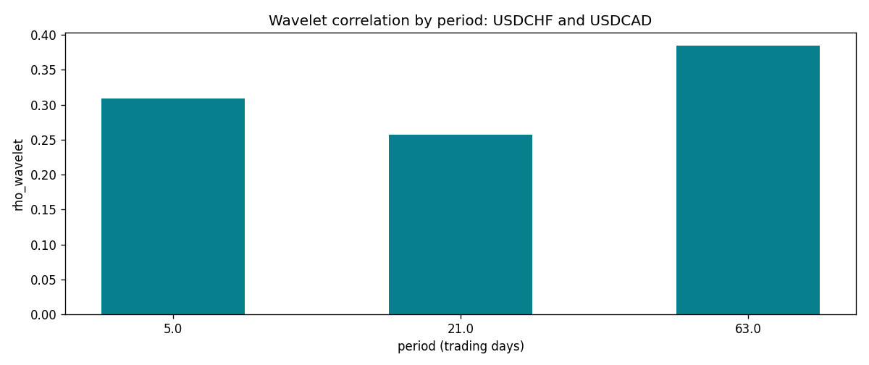

Data report
Matched rows and the scale sheet are in the sibling Excel workbook named USDCHF-USDCAD_Wavelet_D1.xlsx. Embedding all rows as a Word table is impractical; this file holds column summaries and the first and last 15 matched rows.
Columns: time, USDCHF_open, USDCAD_open, USDCHF_high, USDCAD_high, USDCHF_low, USDCAD_low, USDCHF_close, USDCAD_close, USDCHF_tick_volume, USDCAD_tick_volume, USDCHF_spread, USDCAD_spread, USDCHF_real_volume, USDCAD_real_volume, USDCHF_log_return, USDCAD_log_return
Column summaries (matched calculation rows)
column | count | mean | std | min | 25% | 50% | 75% | max
USDCHF_open | 7188 | 1.0975966 | 0.25229688 | 0.72022 | 0.9205375 | 0.989955 | 1.2378 | 1.8219
USDCAD_open | 7188 | 1.2667824 | 0.16892678 | 0.9168 | 1.1183975 | 1.298465 | 1.3720475 | 1.6183
USDCHF_high | 7188 | 1.1028875 | 0.2540352 | 0.73305 | 0.924845 | 0.993545 | 1.242375 | 1.8313
USDCAD_high | 7188 | 1.2716804 | 0.16888565 | 0.9336 | 1.12285 | 1.30387 | 1.37646 | 1.619
USDCHF_low | 7188 | 1.0924772 | 0.25071604 | 0.08565 | 0.91725 | 0.9863 | 1.23155 | 1.8121
USDCAD_low | 7188 | 1.2622243 | 0.16896256 | 0.9056 | 1.114065 | 1.293535 | 1.3677775 | 1.6102
USDCHF_close | 7188 | 1.0975873 | 0.25219296 | 0.72025 | 0.920805 | 0.98995 | 1.2379 | 1.8217
USDCAD_close | 7188 | 1.2667976 | 0.16890032 | 0.916 | 1.118075 | 1.29844 | 1.372365 | 1.6137
USDCHF_tick_volume | 7188 | 74305.244 | 113479.97 | 1 | 12787.25 | 40220 | 70419.75 | 858589
USDCAD_tick_volume | 7188 | 81017.898 | 147302.44 | 1 | 5560 | 40941.5 | 71627 | 1410818
USDCHF_spread | 7188 | 26.050501 | 24.7086 | 0 | 5 | 16 | 50 | 100
USDCAD_spread | 7188 | 23.4399 | 18.261108 | 0 | 9 | 17 | 40 | 60
USDCHF_real_volume | 7188 | 2.3284369e+10 | 8.9116261e+10 | 0 | 0 | 0 | 0 | 1.9331921e+12
USDCAD_real_volume | 7188 | 1.8376704e+10 | 9.6688094e+10 | 0 | 0 | 0 | 0 | 2.5751613e+12
USDCHF_log_return | 7188 | -7.133e-05 | 0.00659527 | -0.19545699 | -0.0033544 | 8.077e-05 | 0.00332477 | 0.09051364
USDCAD_log_return | 7188 | -1.556e-05 | 0.00514382 | -0.03859748 | -0.00283746 | 4.44e-05 | 0.00272629 | 0.03436319
First 15 matched rows (selected columns)
time | USDCHF_log_return | USDCAD_log_return
1999-01-05 | 0.0039424743 | -0.010131666
1999-01-06 | 0.013605652 | -0.0003306769
1999-01-07 | -0.0093883841 | 0.0015202092
1999-01-08 | 0.011040268 | -0.0020495197
1999-01-11 | 0.0052963193 | -0.0035137769
1999-01-12 | -0.0098275602 | 0.0066194721
1999-01-13 | -0.018259701 | 0.0045420214
1999-01-14 | -0.0024256692 | 0.0069376546
1999-01-15 | 0.01794228 | -0.0056905671
1999-01-18 | -0.0031856384 | 0.00098344542
1999-01-19 | -7.2518946e-05 | 0.002748513
1999-01-20 | 0.0072259871 | -0.0059646885
1999-01-21 | -0.0038232689 | -0.0042823796
1999-01-22 | -0.0001445609 | 0.0025057712
1999-01-25 | 0.0024546976 | 0.00085579808
Last 15 matched rows (selected columns)
time | USDCHF_log_return | USDCAD_log_return
2026-10-13 | -0.0024955621 | -0.0046395653
2026-10-14 | 0.0029388325 | 0.0015184751
2026-10-15 | -0.0097855323 | -0.0036101503
2026-10-16 | -0.0036230826 | -0.0034322068
2026-10-19 | 0.0036351779 | -0.0018835331
2026-10-20 | -0.0026281224 | -0.0037066008
2026-10-21 | -0.00040027413 | -0.00084691787
2026-10-22 | -0.0048036381 | -0.0026307268
2026-10-23 | 0.005652514 | 2.85545e-05
2026-10-26 | 0.0018407959 | 5.7106554e-05
2026-10-27 | 0.0026100526 | 0.0025379458
2026-10-28 | -0.0010142111 | -0.0038379274
2026-10-29 | -0.0048680164 | -0.00011436495
2026-10-30 | 0.00071594559 | -0.0010298736
2026-11-02 | -0.0071459744 | 0.00061519094

